**St. Elizabeth Ann Seton Catholic Church**

4595 Snyder Lane Rohnert Park, CA 94928

(707) 585-3708

**Website:** [www.Stelizabethrp.com](http://www.Stelizabethrp.com)

**E-Mail** **[stelizseton@sbcglobal.net (our](mailto:stelizseton@sbcglobal.net%20%20%20%20%20%20%20%20%20%20%20%20%20%20%20%20%20%20%20%20%20%20%20%20%20%20%20(our) old email is back)**

**Office hours: Tuesday-Friday. 9-12:30pm.**

**Church Doors are open from 7:30am.-7pm daily.**

**Sunday, October 20, 2024**

**The 29th Sunday in Ordinary Time**

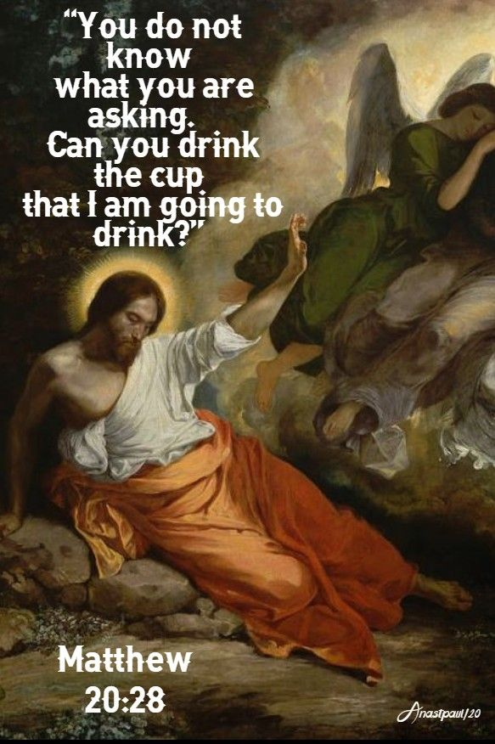

**Pastoral Staff and Extensions**

Rev. Thomas Diaz, Pastor, #4, Day off-Mondays

Chris Giacometti, Office Manager, #1

Mass times: Extension, #2

Jennifer Bedoka, Faith Formation, #3

**Sacraments and Devotions**

**Reconciliation: Sundays 9:45-10:15am. and by appointment.**

**Marriage: One year notice to the pastor.**

**Infant Baptism: Two-month notice. Next class**

**Adult Baptism: “The Welcoming Church” noon in the hall mtg. room.**

**Anointing of the Sick: Please call Fr. Tom.**

**Exposition and Benediction: Thursdays after noon Mass for ½ hr.**

**The Rosary: ½ hr. before weekday Masses.**

**The Divine Chaplet: Tues. after noon Mass**

**Mass Schedule and Intentions**

**Sat. Oct. 19, 4pm.** + Gregorio Cruz Sr.

**Sun. Oct. 20, 8:30am.** + Pat Grundman

**10:30am.** People of the Parish

**Tue. Oct. 22, 12:15pm.** Ints. of All Priests

**Wed. Oct. 23, 8:15am.** + Lydia Leano

**Thu. Oct. 24 12:15pm.** + Joe Vargas

**Fri. Oct 25, 8:15am.** + Steve Richter

**Sat. Oct.26,** **4pm.** + Norma Deleon

**Sun. Oct 27, 8:30am.** People of the Parish

**10:30am.** Ints. of Mike LaPlante

**Events for the Week**

**Oct. 20, 8:30 &10:30am.** Café after Mass

**9:30am.** SVDP Mtg./Cl

**10:30am.** Mass of the Filipino Saints

**noon** The Welcoming Church

**5-** **7pm.** Youth Group/Hall

**Oct.** **22, 1pm.** Bible Study (Minestrone Soup)

**6pm.** Socials Mtg./Cl

**Oct. 25, 5pm.** Family Movie Night/ Trunk-r-

Treat/ Dinner

**Sunday Readings**

**Reading I:** Isaiah 53:10-11**, Reading II:** Hebrews 4:14-16 **Gospel:** Mark 10:35-45

**Sunday Reflection**

**Glory, Glory, Halleluja I**nt he [Gospel](https://bible.usccb.org/bible/readings/102024.cfm#main-content) Reading, James and John ask Jesus if they can sit on his right and on his left in his glory. The other ten apostles are indignant when they learn of it.In response to the apostles’ indignation, Jesus gives them a lesson in glory.On worldly views, the great ones are the rulers. On Jesus’ view, the servants are the truly great ones. Real glory doesn’t come from lording it over others, but from serving others. Jesus is most glorious in his crucifixion, when he has lost everything but love.So Jesus’ response to the indignation of the apostles shows us that they were thinking of glory as kingship. And they were indignant with James and John, because they thought that kind of kingship was what James and John were asking Jesus for.But notice that Jesus does not respond to James and John by explaining to them what true glory is. What Jesus says to James and John shows us what those two apostles were thinking, just as Jesus’ response to the others shows us what they were indignant about.To James and John, Jesus says, “Can you drink the cup that I drink?” This is the cup that Jesus prayed might pass from him. It is his crucifixion. So James and John have the right idea of glory. They are not asking for thrones in heaven, as the other apostles think they are.They are asking whether they might be crucified with Jesus, on either side of him. And here is the most powerful thing to notice in this story. Jesus does not rebuke James and John for their request. He grants it. They *will*drink his cup with him.But Jesus denies them their request to be beside him in his glory. That gift is already prepared by God for others, Jesus says. And which others? Well, for those two thieves, crucified on either side of Jesus. Who else? God gave that great gift that James and John wanted, not to any of the apostles, including James and John, but to two unknown, low-down, petty criminals and what happened?One of those thieves wasted the gift. The other one was glorious, wasn’t he?Eleonore Stump

**Discussion Question:** How far will you go in following Christ?

**Parish Stewardship for October 13th Plate:** $4,139.87. **Deficit for the week $1,861. Building Maintenance:** $1,304. **Thank you! The 2nd collection today is taken up throughout the United States for the Foreign Missions.**

**Please pray for our infirmed:** Aubrey Adams, Andrea Davis, Patrick Dempsey, Marlene Dentoni, Marcella Dorado, Rosita Faltado, Bill Gardon, Jeanette Guidry, Regina Hill, Frank Manhoso, Marcelina Morales, Pat O’Brien, Cavan O’ Connell, Sione Palu, Nicholas Patrick, The Rivas Family, Lora Sansom, Robert Scarpone, Suad Shami, Cecilia Tarrant, Dominique Tarrant, Jim Turegano, Orinia Vanderlind, Malik Whitehorse, and Marilyn Wills.

**The Social Justice Ministry** is coordinating **The Winter Coat Drive** for the homeless people of Rohnert Park throughout the month of October. Receptacles can be found in the vestibule of the church. We have one more week to go. Thank you!

**The Next Wedding Anniversary Mass blessing will be on Oct. 27th at 10:30 Mass.** We skipped it last month because no couples came forward. Please phone the office to let us know if you are coming for a blessing.

**Social Justice Note Thanks to the generosity of our parishioners and the hard work of the Social Justice Ministry, St. Elizabeth Ann Seton Church received the following note from the Unsheltered Friends Outreach.**

“To all St Elizabeth Seton Church

Thank you for being so thoughtful in caring for our homeless friends. Your donations are very much appreciated and the love as well.”

Sincerely,

Unsheltered Friends Outreach

***Faith Formation Ministry***

*Quote of the Week*

**“If you judge people, you have no time to love them.”**

**(Mother Teresa)**

***Sunday, October 20th***

***9:30 am*** *1st Year Confirmation/cl*

***10:30 am*** *Children’s Liturgy of the Word*

***12 pm Mandatory Parent Meeting-Prayer***

***5-6:30 pm*** *Atrium Level 3*

***5-7 pm*** *Youth Group/hall*

***Tuesday, October 21st***

***4-5:30 pm*** *Atrium Level 1 & Level 2*

***Wednesday, October 22nd***

***2-3 pm*** *1st Year First Communion/cl*

***3:30-4:30 pm*** *2nd Year First Communion/c*

***Sunday, October 27th***

***9:30 am*** *1st Year Confirmation/cl*

***10:30 am*** *Children’s Liturgy of the Word*

***5-6:30 pm*** *Atrium Level 3*

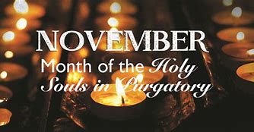***5-6:30 pm*** *2nd Year Confirmation/cl*

November, the month of All Souls, is approaching. As, in the past most of the Mass intentions have been blocked off so the names of those who have died will be mentioned. I am asking that you print the names of those who have died, no more than six, (Mr. and Mrs. George King would be one as they are a couple) and e-mail them to the parish office so a list can be made**. Every year there are problems trying to read people’s handwriting of names and so we ask that you send the names via e-mail during this month of October to,** [**stelizseton@sbcglobal.net**](mailto:stelizseton@sbcglobal.net%20%20%20%20%20%20%20%20%20%20%20%20%20%20%20%20%20%20%20%20%20%20%20%20%20%20%20(our)

**Children of all Ages Friday October 25th Free Halloween Festivity for Family Movie night for** kids of all ages

We will have

TRUNK OR TREAT

around the fountain

from 5-6 pm hosted by the ministries of our parish and a free dinner with chips.

Wear a costume!

**Come join us and have fun!**

Bring your sleeping bags or blanket to sit on the hall floor and we will have some chairs for the older kids

🎃👻

Please sign-up next to the SCRIP table if you wish to attend the event

 **The family movie**

**will begin at**

**6pm.**

begin at 6pm.

**Christmas is Coming!**

St. Vincent de Paul Society

**There will be a second collection for the Society of St. Vincent de Paul next weekend, October 26th and 27th.**  We are preparing for our Christmas Basket program in which we bring a turkey, ham or chicken and a bag of Christmas dinner staples.  Without this our families would not be able to afford a decent meal for Christmas.

We continue to receive calls for assistance Monday through Friday throughout the year.   Our ministry of assisting local families in need with food and household essentials is only possible through the parish joining with us in doing Gods' work with your financial generosity.

Thank you for helping us help others! The St. Vincent de Paul Society

**Coming Events**

1. **Fri, Oct 25th Halloween Festivity from 5-8pm.**
2. **Fri, Nov 1st All Saints Day Masses noon & 7pm. A Holy Day of Obligation**
3. **Sat. Nov 2nd All Souls Day Mass 9am.**
4. **Sat and Sun Nov 2 & 3 Crafts Faire by the Women’s Guild**

**Saint for the Week**

**St John Paul Il Tue. Oct 22nd**

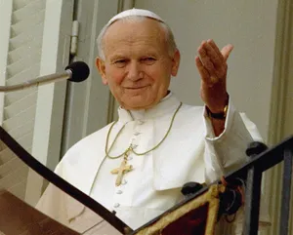 He was the first non-[Italian](https://www.britannica.com/place/Italy) [pope](https://www.britannica.com/topic/pope) in 455 years and the first from a Slavic [country](https://www.britannica.com/topic/nation-state). His [pontificate](https://www.britannica.com/topic/papacy) of more than 26 years was the third longest in history. As part of his effort to promote greater understanding between nations and between [religions](https://www.britannica.com/topic/religion), he undertook numerous trips abroad, traveling far greater distances than had all other popes [combined](https://www.britannica.com/dictionary/combined), and he extended his influence beyond the [church](https://www.britannica.com/topic/church-Christianity) by campaigning against political oppression and criticizing the materialism of the West. He also issued several unprecedented apologies to groups that historically had been wronged by Catholics, most notably Jews and [Muslims](https://www.britannica.com/topic/Islam). His unabashed [Polish](https://www.britannica.com/place/Poland) [nationalism](https://www.britannica.com/topic/nationalism) and his emphasis on nonviolent political activism aided the [Solidarity](https://www.britannica.com/topic/Solidarity) movement in communist Poland in the 1980s and ultimately contributed to the peaceful dissolution of the [Soviet Union](https://www.britannica.com/place/Soviet-Union) in 1991. More generally, [John Paul](https://www.britannica.com/biography/John-Paul-Jones-United-States-naval-officer) used his influence among Catholics and throughout the world to advance the recognition of human dignity and to deter the use of [violence](https://www.britannica.com/topic/violence). His centralized style of church governance, however, [dismayed](https://www.britannica.com/dictionary/dismayed) some members of the clergy, who found it autocratic and stifling. He failed to reverse an overall decline in the numbers of [priests](https://www.britannica.com/topic/priest-Christianity) and [nuns](https://www.britannica.com/topic/nun-monasticism), and his traditional interpretations of church teachings on personal and sexual [morality](https://www.britannica.com/topic/morality) alienated some segments of the laity

**Ministry Schedule for October 19th & 20th**

**4pm Mass**

**Readers:** Tony Madia, Caroline Stevens

**EMS:** Janice Dyer, Dianne Foppoli, Linda Mish **Ushers:** Olivia Salazar, Dianne Foppoli **Greeters:** Roxanne Bialkoski, Beatriz Vega

**8:30 Mass**

**Readers:** Scott Crossen, Liz Ritchie

**EMS:** Armando Argueta, Maureen Sheridan Scott, Linda Biondini

**Ushers:** Gus & Liz Chang

**Greeters:** Pam Burgess, Mary Thayer

**10:30 Mass**

**Filipino Ministers**

**October 26th & 27th**

**4pm Mass**

**Reader:** Heigi Pillar, Linda Anderson

**EMS:** Jovita Bishop, Luisa Bustillos, Beth Turegano

**Ushers:** Mark& Selina Johnson

**Greeters:** Debra Ciarasso, Olivia Salazar

**8:30am Mass**

**Readers:** Maria Van Anne, Phillip Alvarado

**EMS:** Dave Grundman, Remie Alinas, Mary Thayer

**Ushers:** Maureen Sheridan Scott, Diane Cook

**Greeters:** Alan & Caroline Kalaw

**10:30am Mass**

**Readers:** Scott Morrical, Caroline Stevens

**EMS:** Bill Yates, Mila Morrical, Nativity Mata

**Ushers:** Linda Shane, Sally Shami

**Greeters:** Julie La Plante, Pat Yates

**Pastor’s Corner**

**I want to thank** all those who prayed for me on the retreat. It was a good time to see my fellow priests, slow down in silence and do spiritual reading.

I am looking at getting a new water machine for the vestibule as the one we have is not sanitary and does not work properly.

The flowers around the fountain will be coming out shortly to prepare the area for winter spring flowers. I that Luisa Bustillos and Sally Shami for the watering and keeping the flowers blooming.

**Are you participating in the Diocesan Annual Appeal?** Any money received as we have gone beyond the monetary goal goes to the parish, which we need as some people do not give enough to the parish on a weekly basis. We now have 606 families on the books and that means 28% have participated, 171 parishioners. Where is everyone else?

**Thank you** to Marie Felis for the flowers last week in the sanctuary and to Kate Ingram for the flowers this weekend.

**I want to thank** all those who worked atthe Tr-Tip Dinner last weekend: the set-up crew, the kitchen crew, the bartenders, the ticket takers, the take down crew, and especially our butchers and BBQers. We made $3,200 for the event.